CURRICULUM VITAE

Ajith P
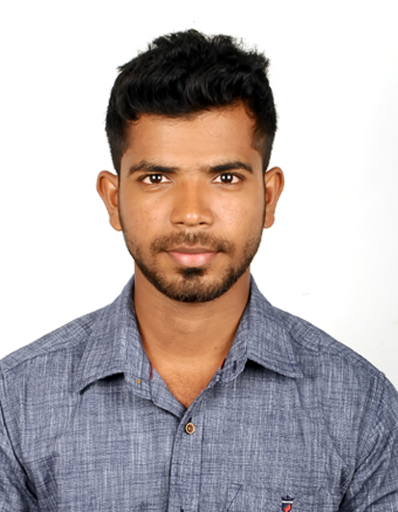
Cell +919790895574
Email: ajith4001@gmail.com

I am looking for an opportunity to be part of an organization where I can learn
on the job, exhibit my Talent and apply my skills. I will provide my best effort in
ensuring to show excellence in all my work with enthusiasm and take up
responsibility for the job assigned.

EDUCATIONAL & PROFESSIONAL QUALIFICATION

- SSLC – Madambakkam Government Higher Secondary School.
- HSC – C.S.I. Corley Higher Secondary School.
- BCA – (Computer Application) New Prince Shri Bhavani Arts & Science College.

WORKING QUALIFICATION:
AGILITY – Integrated Logistics:-

EXPERIENCE:

Agility logistics - GIL shared services center from Nov 2016 to Till Date

Team: CLIENT ID & FOCiS (Freight Operations Customer Information System)
Process Knowledge in Client ID Validation and Approval Maintaining Governance
Process. Create Product code & Hierarchy Tree.
ROLE: Process Associate

TOOLS & LIBRARIES:
- Log-Net – Application for amending container information, tracking Details.
- Focis – Application to extract stuffing documents.
Nature of Work:
- Have handled Origin Activities (Purchase order follow-up and origin Cargo Management & PO consolidation) for all APAC (Asia Pacific) regions like Malaysia, china, India, Korea, etc.,
- Process milestones like (Booking, Shipment, Container, Document verification) for all off-line regions.
- Generated the Report at Each Milestone’s to show up Overdue and To-be Overdue PO's and Allocate the Container and Cargo loading report, Monthly volume report for customer wise.
- Have handled Customer and Destination Query’s need to tracker cargo from origin to destination end to end.

PERSONAL STRENGTHS:

- Excellent grasping power, Ability to learn more from experienced people, Creativity and Dynamism with adaptive and team oriented style and Creative, quick-learner, self-motivated, strong inter-personal skills.

PERSONAL DETAIL:
Father Name : Padmakumar
Date of Birth : 2nd Nov 1994

Gender : Male
Address : No.27, Dwarakapuri, Sudharsan Nagar,
Madambakkam, Chennai-600126.
Nationality : Indian
Language : English, Tamil

DECLARATION

I hereby declare that all the above-mentioned information are true and correct to my knowledge and belief.

Place: Chennai Signature,
Date: Ajith P

